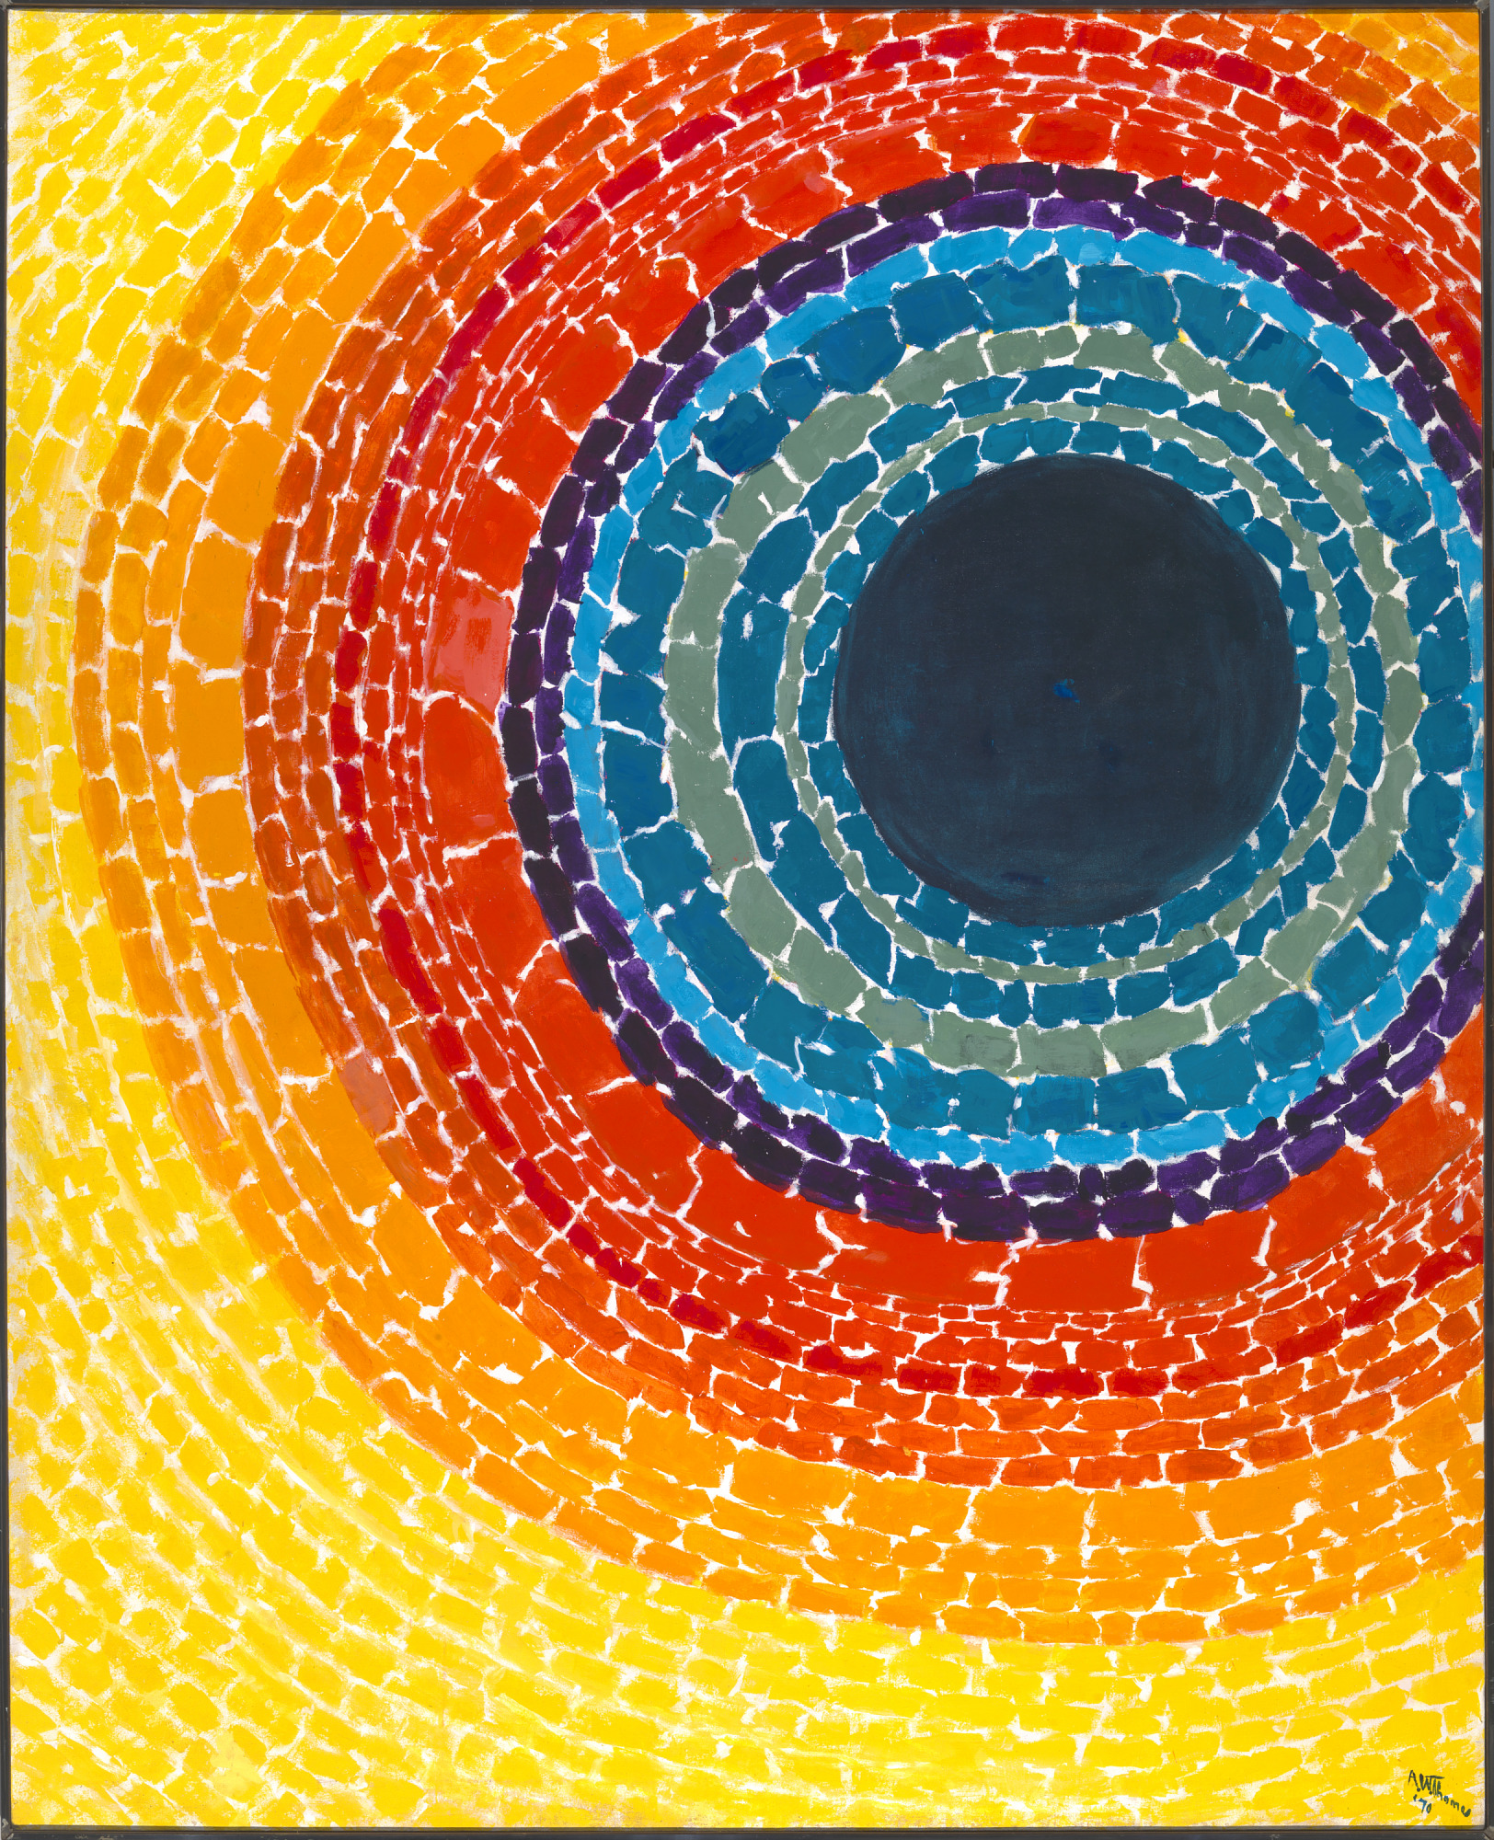

- Type: Artwork (acrylic paint on canvas)
- Artwork title and publication date: The Eclipse, 1970
- Artist: Alma Thomas (1891–1978)
- Artwork description: “The Eclipse” captures the dramatic and radiant effects of a solar eclipse with a composition of bold, intersecting shapes and vibrant hues.
- More information at: The Eclipse - Smithsonian American Art Museum
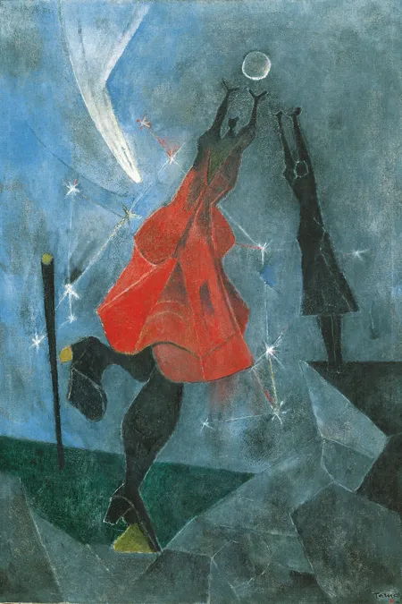

- Type: Artwork (oil paint on canvas)
- Artwork title and publication date: Mujeres Alcanzando la Luna (Reaching for the Moon), 1946
- Artist: Rufino Tamayo (1899–1991)
- Artwork description: "Reaching for the Moon" depicts two figures reaching up toward the Moon with a constellation of stars and a comet whizzing by in the background.
- More information at: The Mexican Artist Determined to Paint Multidimensional Women - New York Magazine
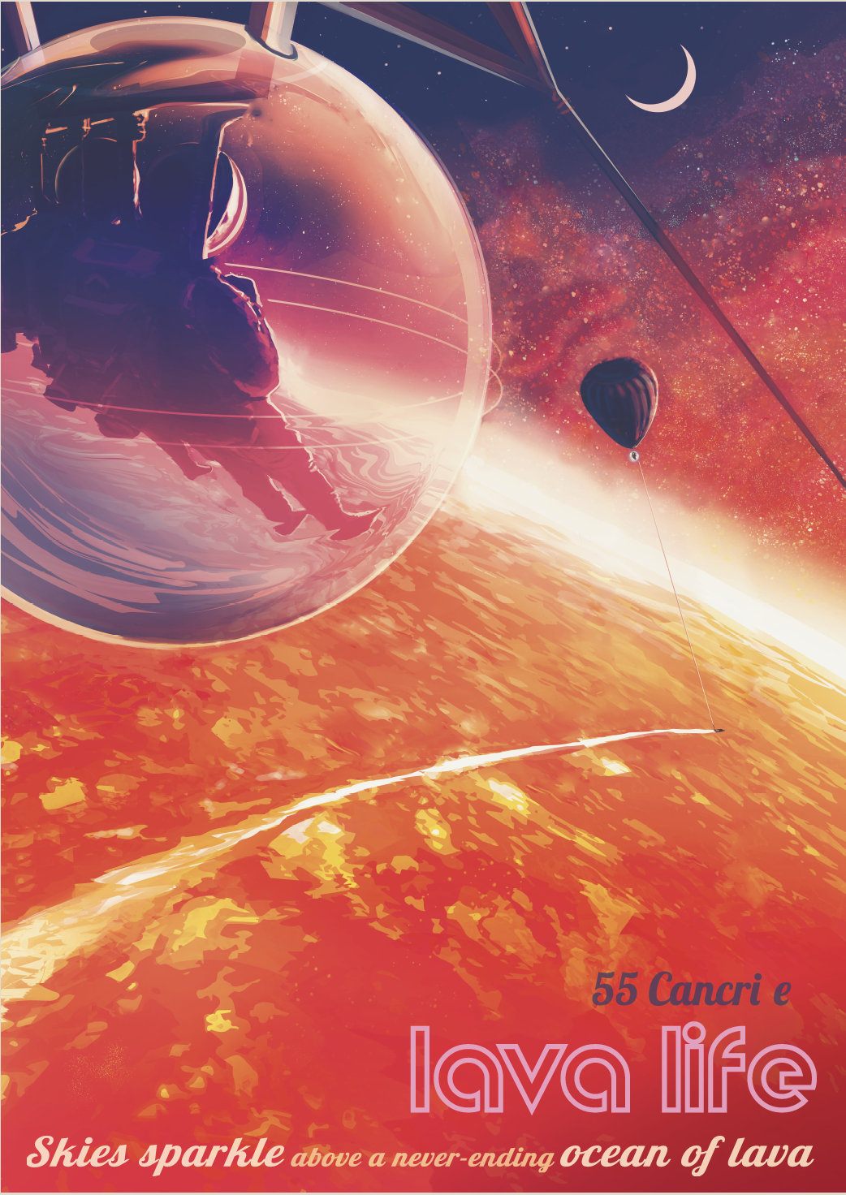

- Type: Artwork (digital poster)
- Artwork title and publication date: 55 Cancri e: Skies Sparkle Above a Never-Ending Ocean of Lava, NASA’s Exoplanet Travel Bureau poster series, 2018
- Artist: NASA-JPL/Caltech
- Artwork description: This poster imagines a real exoplanet - Janssen (55 Cancri e) - as a fictitious, extreme vacation destination. The planet’s surface features a molten lava ocean. In the dark sky, there are views of its sister planet, Galileo, and the star Copernicus.
- More information at: 1) NASA Exoplanets - 55 Cancri e, 2) 55 Cancri e: Skies Sparkle Above a Never-Ending Ocean of Lava
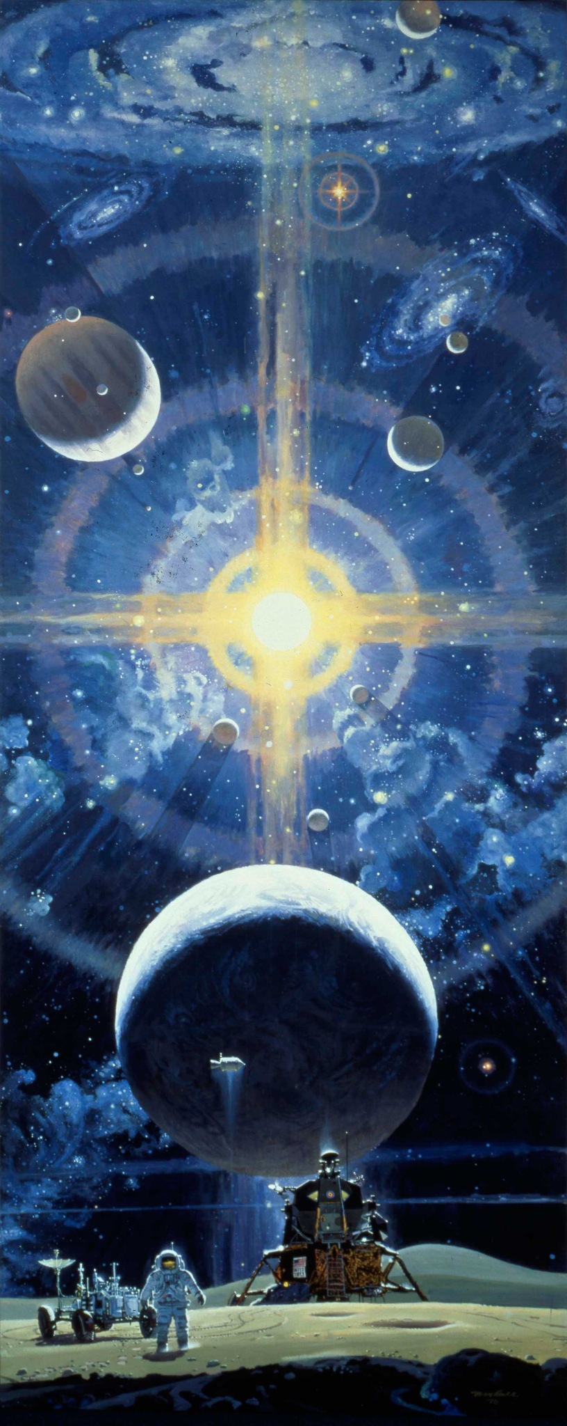
- Type: Artwork (wall mural; acrylic paint on canvas)
- Artwork title and publication date: The Space Mural - A Cosmic View, 1976
- Artist: Robert McCall (1919–2010)
- Artwork description: The mural presents a sweeping cosmic vista that depicts a dynamic and colorful vision of space exploration. The mural includes spacecraft, several swirling galaxies, exoplanets, and an astronaut on the Moon’s surface.
- More information at: 1) Robert McCall’s Vision of the Universe - NASM, 2) The Space Mural - McCall Studios, 3) The Space Mural: A Cosmic View in South Lobby - NASM
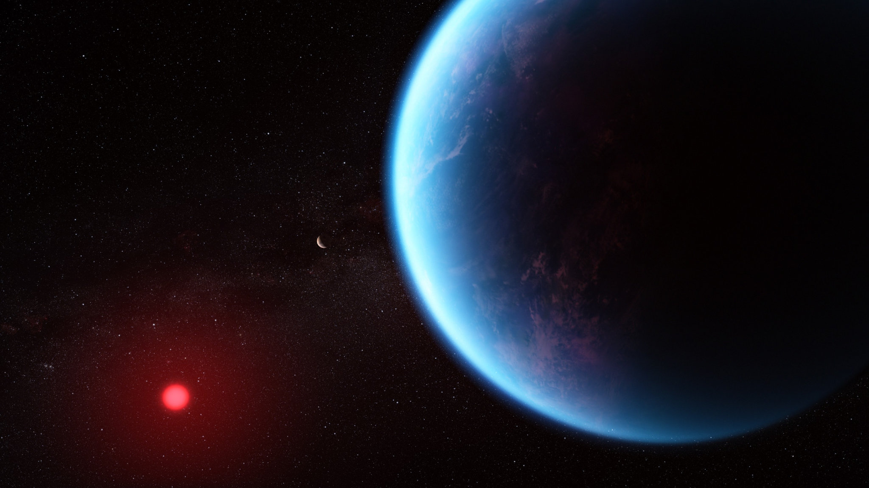

- Type: Scientific illustration
- Illustration title: Exoplanet K2-18 b and its Star (Scientific illustration)
- Publication date: September 11, 2023
- Scientific illustrator: Joseph Olmsted, Space Telescope Science Institute (STScI)
- Illustration description: This illustration depicts exoplanet K2-18 b, which is 8.6 times the mass of Earth and orbits within the habitable zone of the cool dwarf star K2-18, located 120 light-years away from Earth. The artwork draws from scientific data to visualize what this distant world might look like.
- More information at: Exoplanet K2-18 b (Illustration) - Astropix

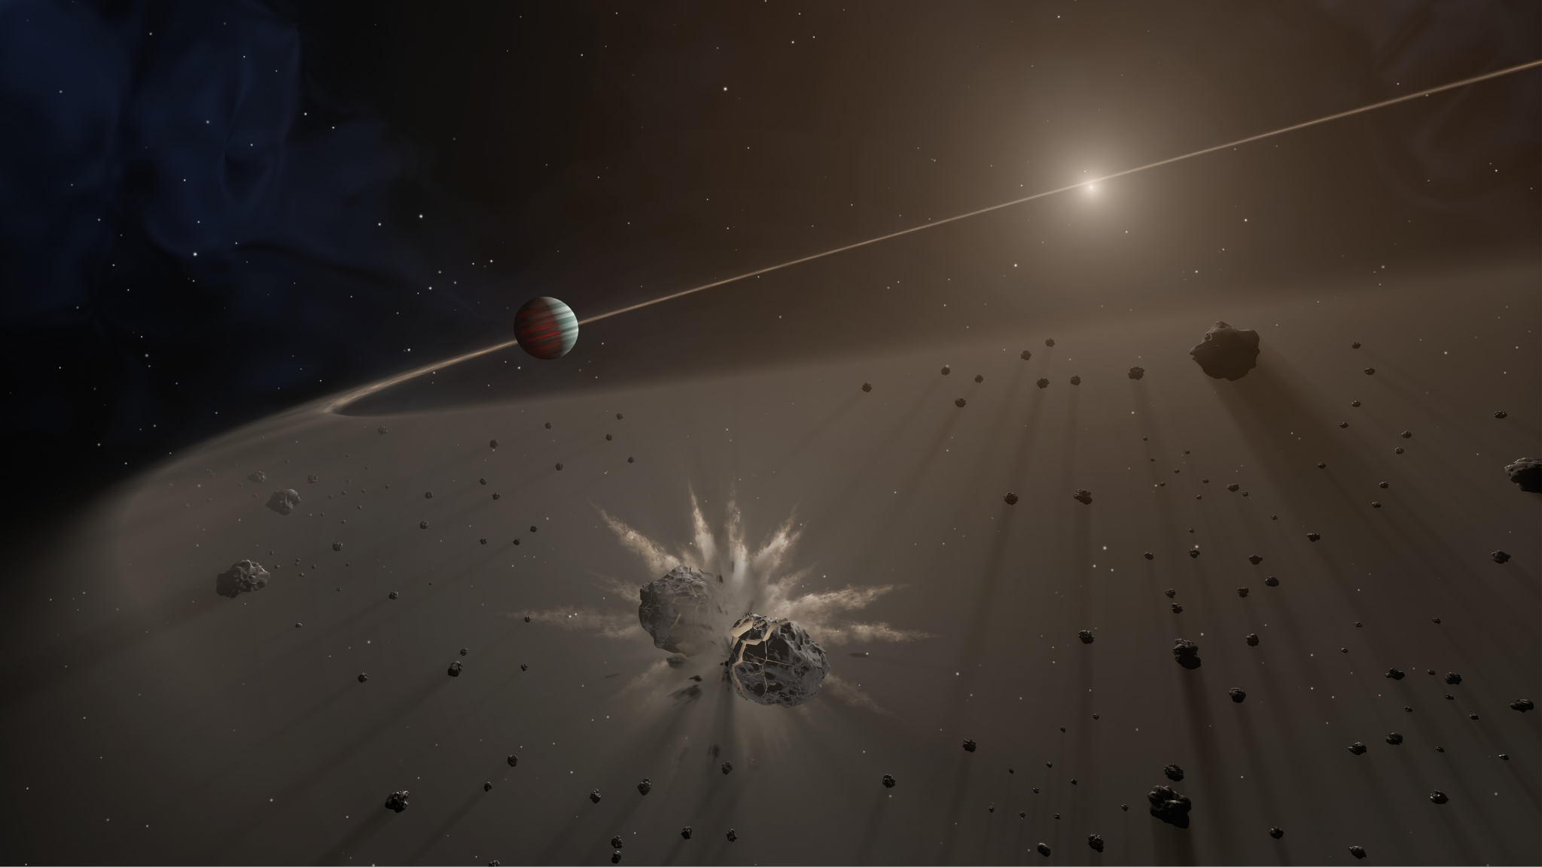

- Type: Scientific illustration
- Illustration title: Giant Exoplanet and Debris Disk
- Publication date: October 11, 2017
- Scientific illustrator: Tim Pyle, Caltech/IPAC
- Illustration description: This artist's rendering shows a giant exoplanet causing small bodies to collide in a disk of dust. A distant star that the giant exoplanet is orbiting can be seen in the distance.
- More information at: Giant Exoplanet and Debris Disk - AstroPix

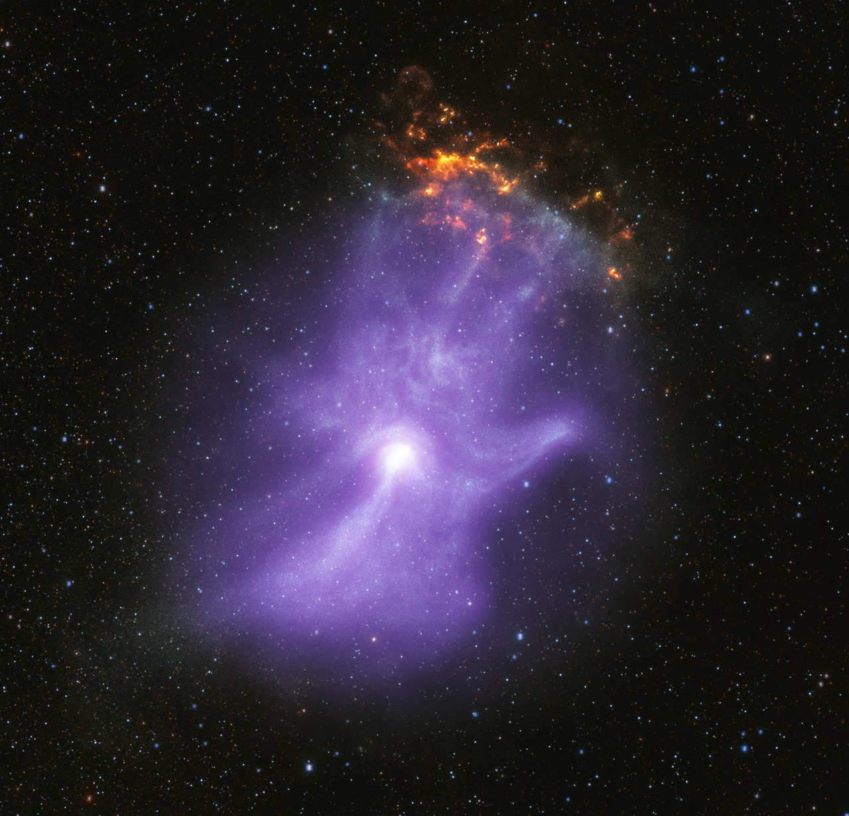

- Type: Astronomical image
- Astronomical object type and name: Pulsar Wind Nebula, MSH 15-52
- Observatories: Chandra X-Ray Observatory, IXPE, and Dark Energy Camera
- Image release date: October 30, 2023
- Wavelengths of light: X-ray and Infrared
- Image processing: Chandra X-ray Observatory
- Image description: This image combines X-ray data from Chandra and IXPE with infrared data from the Dark Energy Camera and reveals how a young pulsar injects particles into space, creating a pulsar wind nebula. The nebula, known as MSH 15-52, has a shape resembling a human hand and offers insight into the formation of such objects.
- More information at: X-ray Telescopes Reveal the "Bones" of a Ghostly Cosmic Hand - AstroPix
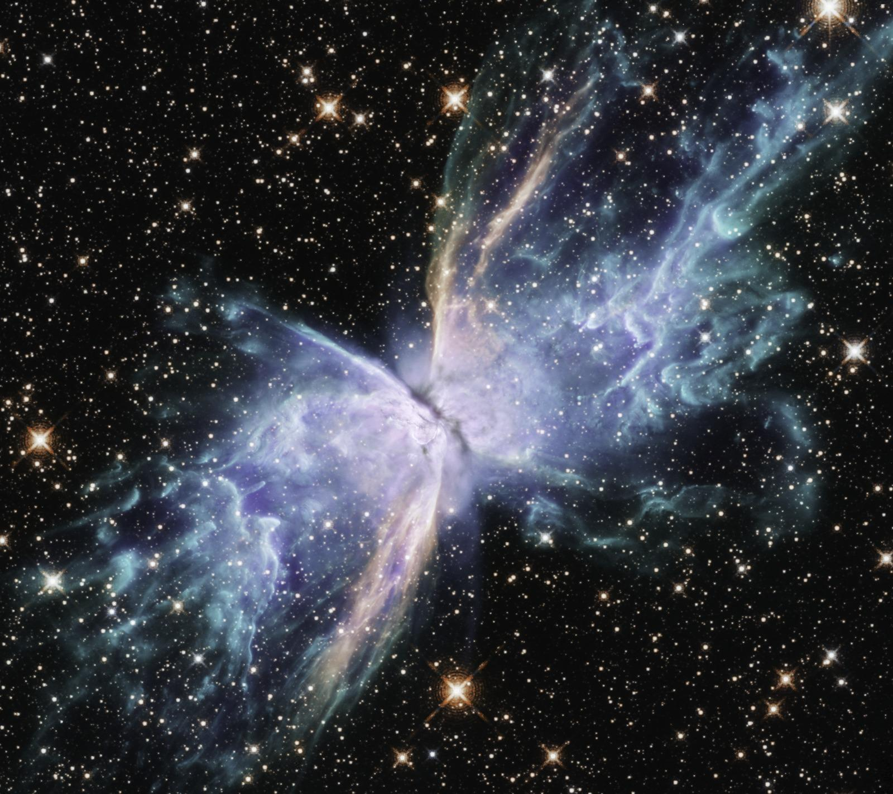
- Type: Astronomical image
- Astronomical object type and name: Planetary Nebula, NGC 6302 (Butterfly Nebula)
- Observatory: Hubble Space Telescope
- Image release date: June 18, 2020
- Wavelengths of light: Visible and Infrared
- Image processing: ESA/Hubble
- Image description: This Hubble Space Telescope image reveals NGC 6302, the Butterfly Nebula, located about 3,800 light-years away in the constellation Scorpius. The nebula, shaped like a butterfly, spans over two light-years and was formed from the outer layers of an expelled star.
- More information at: NGC 6302 - AstroPix
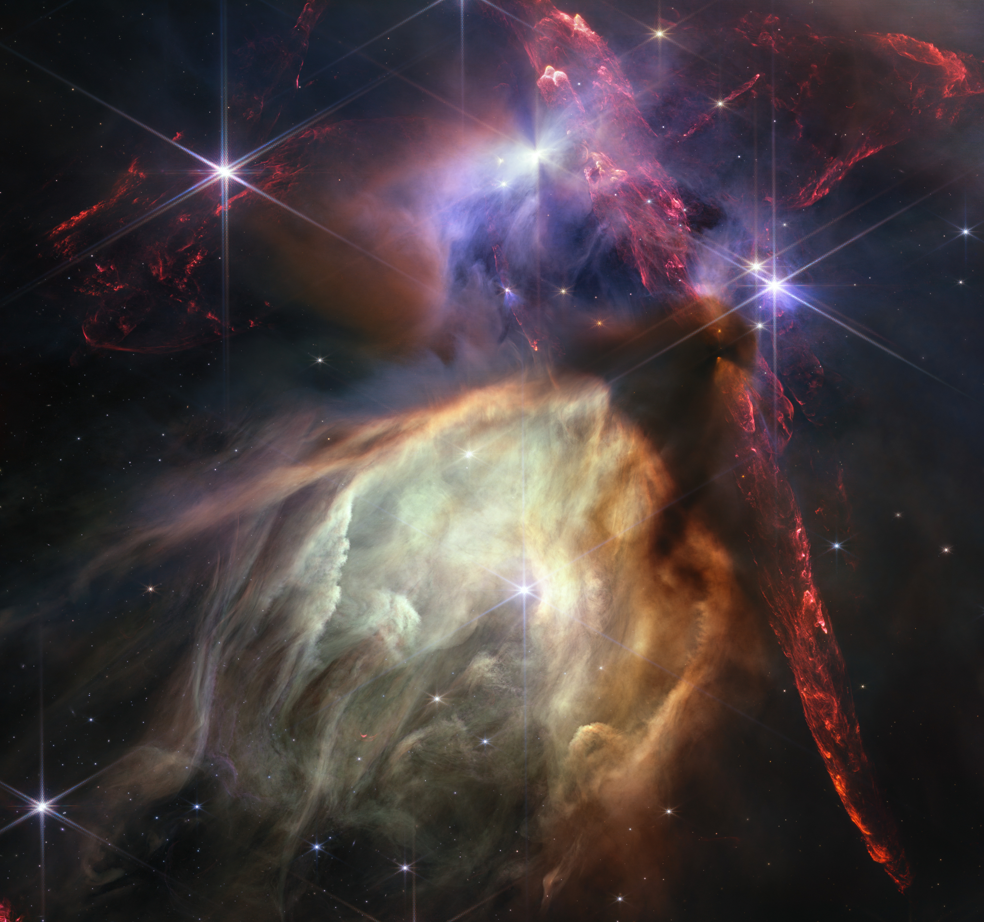
- Type: Astronomical image
- Astronomical object type and name: Stellar Nursery, Rho Ophiuchi Cloud Complex
- Observatory: James Webb Space Telescope
- Image release date: July 12, 2023
- Wavelengths of light: Near-infrared
- Image processing: Space Telescope Science Institute (STScI)
- Image description: This image from NASA’s James Webb Space Telescope captures the chaotic star-forming region of the Rho Ophiuchi cloud complex, the closest stellar nursery to Earth. The image reveals jets from young stars that light up molecular hydrogen and circumstellar disks that may form future planetary systems. The star S1, the most massive in the image, is seen carving out a glowing cave with its stellar winds.
- More information at: Rho Ophiuchi (NIRCam Image) - AstroPix
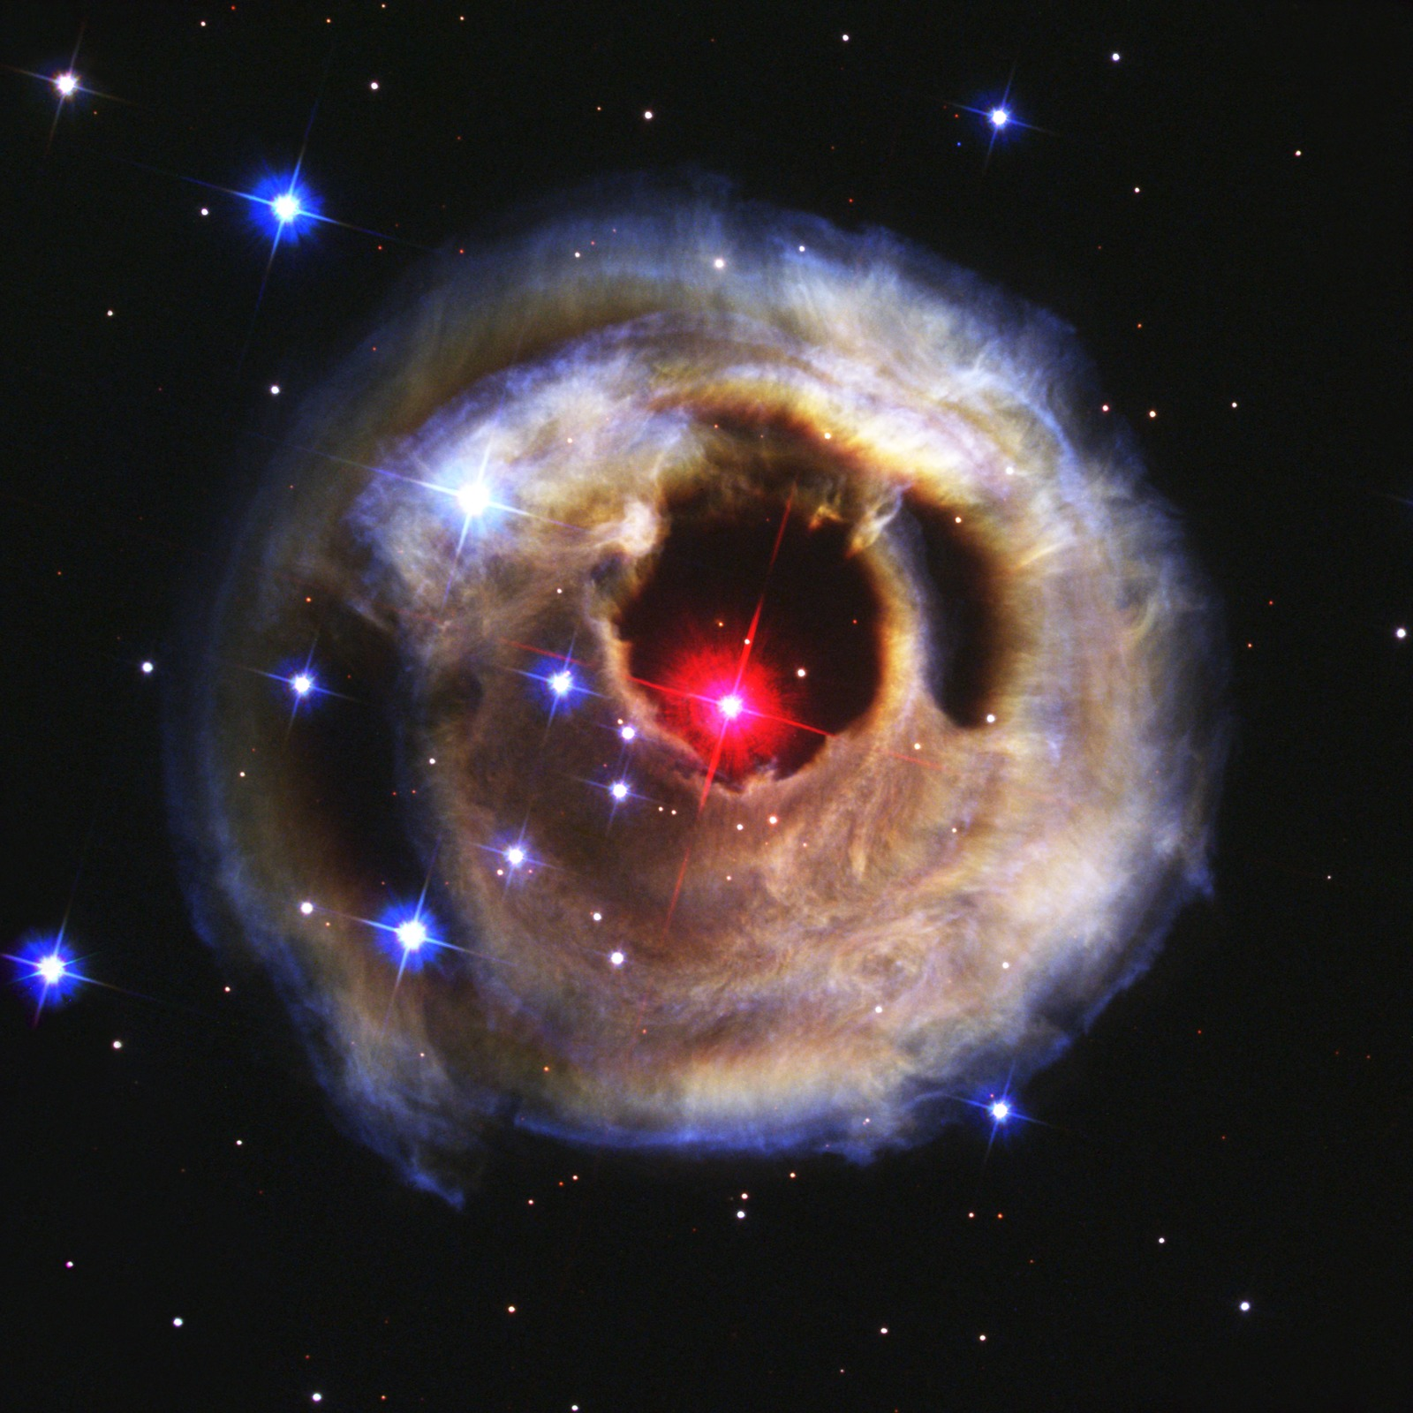
- Type: Astronomical image
- Astronomical object type and name: Transient Variable Star, V838 Monocerotis
- Observatory: Hubble Space Telescope
- Image release date: March 26, 2003
- Wavelengths of light: Visible
- Image processing: Space Telescope Science Institute (STScI)
- Image description: In 2002, the star V838 Monocerotis experienced a sudden brightening, creating a pulse of light that illuminated the surrounding dust layers. This "light echo" allowed the Hubble Space Telescope to capture the star's expanding reflection off the dust.
- More information at: Light Echo From Star V838 Monocerotis - December 17, 2002 AstroPix
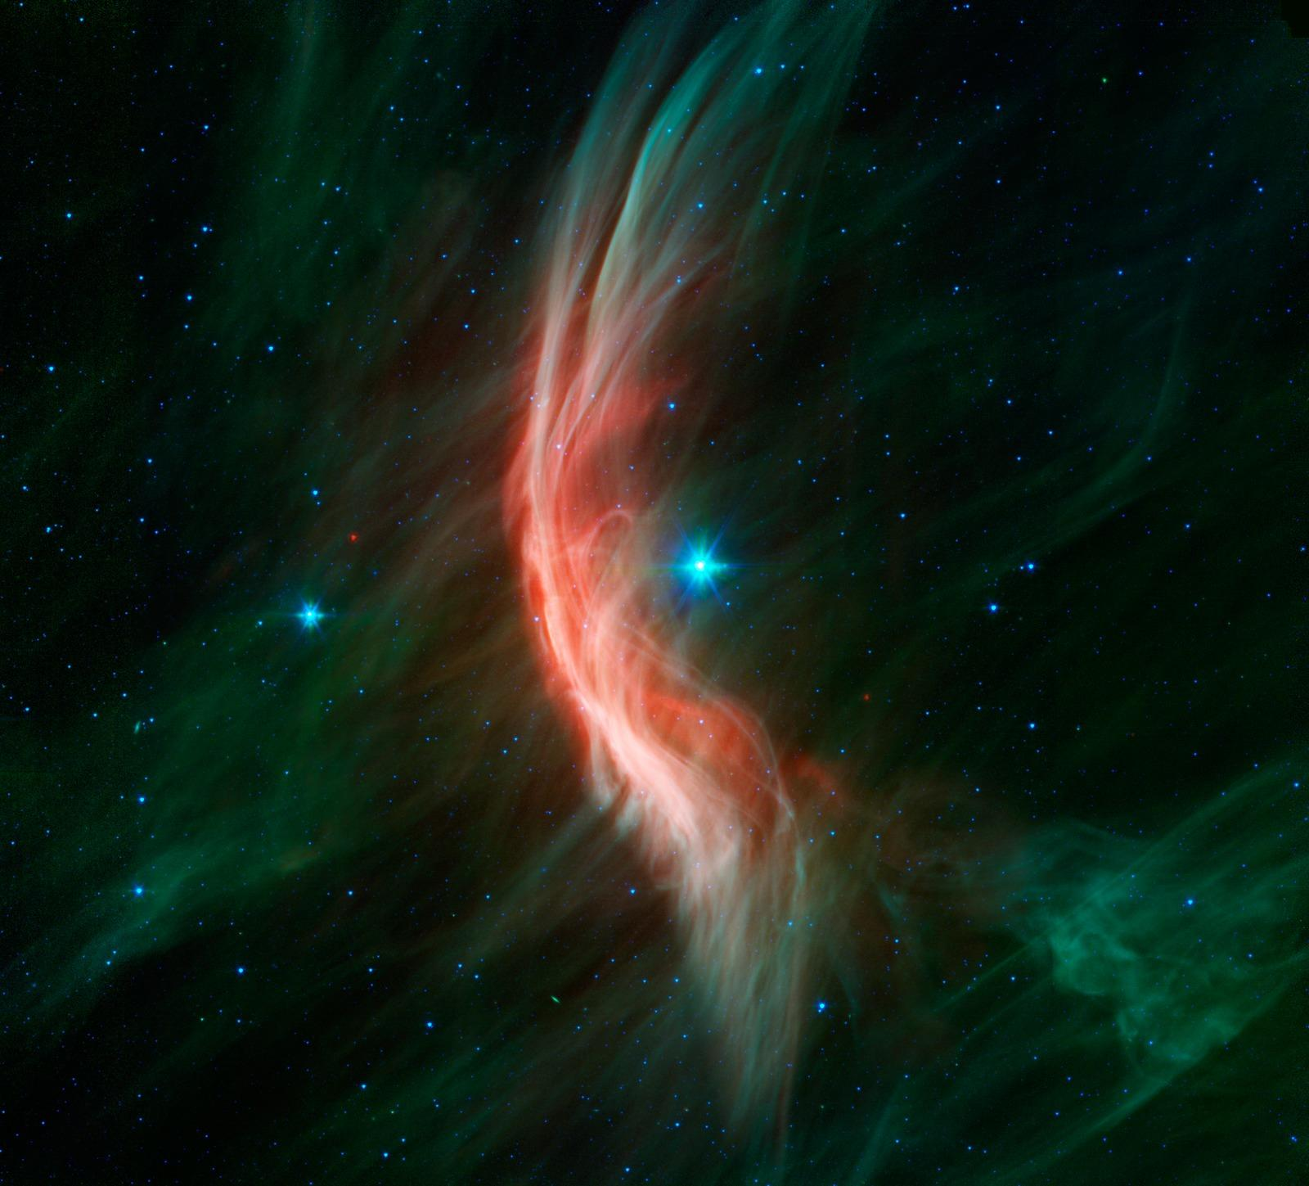
- Type: Astronomical image
- Astronomical object type and name: A Massive Main Sequence Star, Zeta Ophiuchi
- Observatory: Spitzer Space Telescope
- Image release date: December 18, 2012
- Wavelengths of light: Infrared
- Image processing: Spitzer Space Telescope, NASA Jet Propulsion Laboratory
- Image description: This image shows Zeta Ophiuchi, a massive, fast-moving star. Much like a ship moving through water, it is creating a stunning bow shock as its powerful stellar winds collide with surrounding interstellar gas and dust. This shock wave, captured by NASA’s Spitzer Space Telescope, forms glowing threads and highlights the star’s dramatic impact on its surroundings.
- More information at: Massive Star Makes Waves - Spitzer Space Telescope
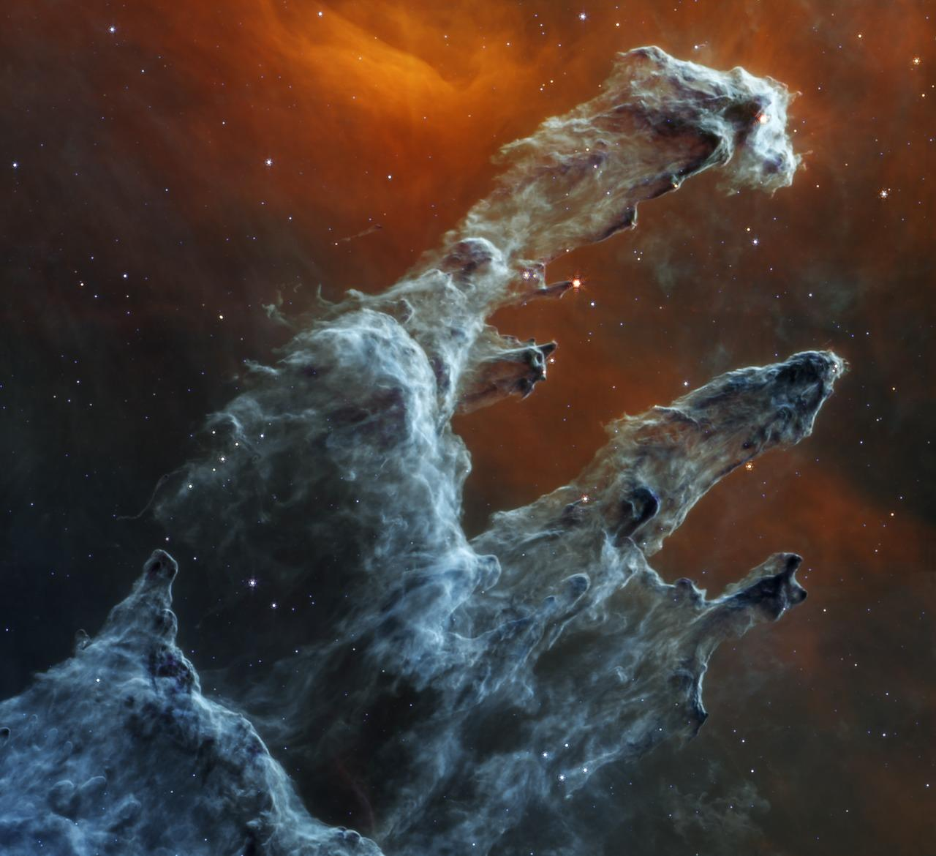
- Type: Astronomical image
- Astronomical object type and name: Star-forming Nebula, the Pillars of Creation (part of the Eagle Nebula)
- Observatory: James Webb Space Telescope
- Image release date: October 31, 2022
- Wavelengths of light: Mid-infrared
- Image processing: Space Telescope Science Institute (STScI)
- Image description: NASA’s James Webb Space Telescope’s mid-infrared view of the Pillars of Creation reveals a haunting landscape where stars fade into the background, and intricate layers of gas and dust dominate. This image, captured by the Mid-Infrared Instrument (MIRI), highlights the dense star-forming regions within the pillars, offering new insights into the birth of stars hidden within these cosmic structures.
- More information at: Pillars of Creation (MIRI Image) - AstroPix

